Topic 4: TRIGONOMETRIC RATIOS
Triangles are in fact one of the most relatable 2-D shape that exist in reality. The very formation of basic novice shapes stem from the manipulation of three-sided forms and their conversion into different creative designs as the youth see fit.
Objectives:
At the end of this session, the student will be able to:
- Find sine, cosine and tangent of acute angles.
- Determine length of chord using trigonometric ratio.
- Solve questions using the application of trigonometric ratios.
Trigonometry is the study of three-sided 2-D shapes generally referred to as Triangles. We study triangles in relation to their sides and the angles between them. With these sides and angles, comes basic calculations attributed to them. These basic calculations are termed as Trigonometric Ratios.
TRIGONOMETRIC RATIOS
The trigonometric ratios are deduced in terms of right-angled triangles (i.e. one angle is exactly 90$°,$thus making the other two angles acute. To this end, we must define the names of the sides of a right- angled triangle.
Given a basic right-angled Triangle ABC, such that, /AC/, which is the side facing the right-angle, is the HYPOTHENUS.

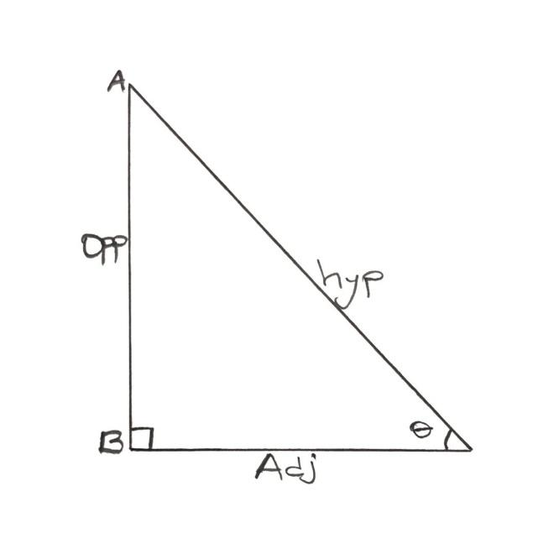

The naming of the other two sides depends on the position of the calculated acute-angle. Consider the acute angle at C. Then, /AB/ is the side facing the acute angle, and s called the OPPOSITE. The last side, /BC/ is called the ADJACENT.
Trigonometric ratios serve to create a relationship between the acute angle and the sides. Thus, using the angle “$θ$” at C in the triangle ABC,
Sin $θ=\frac{opp}{hyp}$
Cos $θ$=$\frac{adj}{hyp}$
Tan $θ= \frac{opp}{adj}$
This is the popular SOHCAHTOA representation.
The Sine, Cosine and Tangent functions represent the basic rewrite them in terms of their reciprocals.
Cosec $θ=\frac{1}{Sinθ}=\frac{hyp}{opp}$
Sec $θ=\frac{1}{cosθ}=\frac{hyp}{adj}$
Cot $θ=\frac{1}{tanθ}=\frac{adj}{opp}$
TABLE OF TRIGONOMETRIC RATIOS
We shall consider the Natural Trigonometric Table of the sine, cosine and tangents of values between 0$°$ and 90$°.$This is because the range of values for an acute angle is 0$°≤θ≤90°.$ This nonetheless includes the decimal values that fall within this range, to 2 decimal places at most .
Trivia: The decimal numbers are convertible into their “seconds equivalent” which is easily read on the Trigonometric Table.
Example:
$$θ=30°{42}^{'} means 30° degrees, 42 seconds, which can be converted$$
$$θ=30°+(\frac{42}{60} )°$$
$$θ=30.7°$$
Similarly,
$$θ=33.73°=33°+0.73°$$
= 33$°+{\left(0.73 ×60\right)}^{'}$
= 33$°44'$
To read the Trig. Table, the whole number part of the angle is traced UNDER the “seconds” column, which are arranged in multiples of 6, in the DIFFERENCE of “1 to 5” which is the range of values between each multiple of 6. For instance,
$$θ=30°{42}^{'}is calculated as "30 UNDER 42 DIFFERENCE 0"$$
Since 42 is a multiple of 6
$$θ=33.73°=33°{44}^{'}is calculated as 33 UNDER 42 DIFFERENCE 2$$
Since 42 is the multiple of 6 and 44-42 = 2$→44=42+2$

USING TRIGONOMETRIC RATIOS TO DETERMINE LENGTH OF CHORD
Consider the chord within a circle, described as
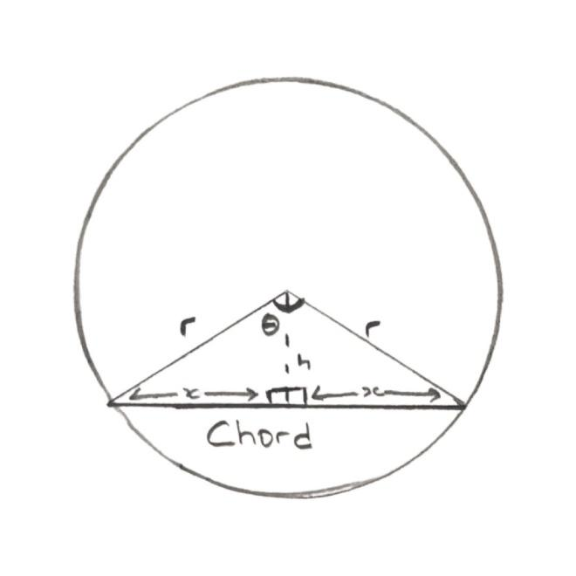

Using the angle $θ$subtended in the center of the circle, bisecting the resulting triangle into two equal right-angled triangles, the angle $θ$ is also split into two. Let $∝=\frac{θ}{2}$
The hypotenuse is side, r and the adjacent is side h; Sin $∝=\frac{x}{r}$
Thus, length of chord = 2 $×rsin∝ since x=rsin∝$
= 2rsin$∝or 2rsin(\frac{θ}{2})$
TRIVIA:
The range of trigonometric values for 0$≤θ≤90° is mirrored directly into the values for 0≤θ≤360°.$This is represented by the C.A.S.T 4 – Quadrant System.

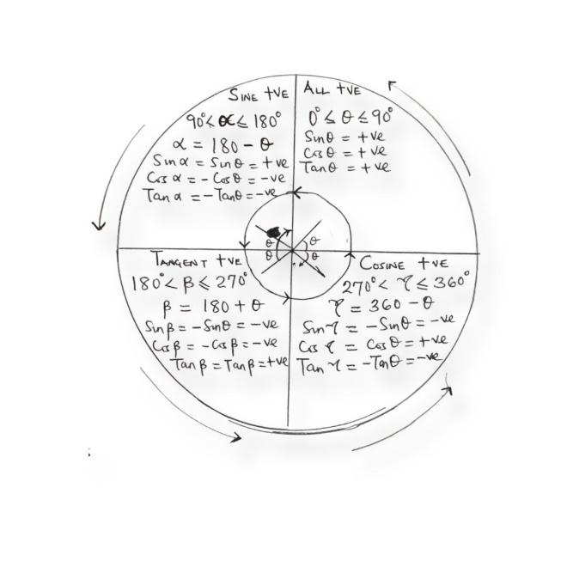
Examples:
- Sin 120$°$
First, we identify the quadrant for 120$°$
Since 90$≤120≤180°, then θ=120° falls into the 2nd Quadrant.$
Since 120= 180 - $θ$
$θ=180-120=60°$
Sin 120$°=sinsin \left(180-θ°\right) =sinsin 60°$
Using the trigonometric table for natural sine
Sin 120$°=sin60°=0.8660$
- Cos 250$°$
250$°$ falls in the 3rd Quadrant, since 180$°<250°<270°$
250 = 180 + $θ$
$θ=250-180$ =70$°$
Only Tan $θ is positive in the 3rd Quadrant, so$
Cos 250$°= -coscos 70°= -0.3420$
- Calculate the length of the chord between two radii from the center of the circle with an angle subtended at 49$°$ with radius 10m.
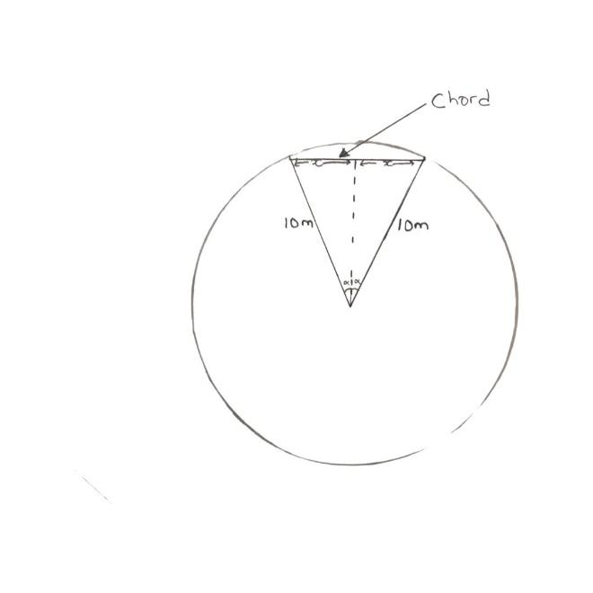

$$θ=49° r=10m$$
Let $∝=\frac{θ}{2}$, then sin $∝=\frac{x}{10}$
x= 10sin $∝$
x= 10 sin ($\frac{θ}{2})$
length of chord =2x
thus,
length of chord = 2x= 2(10sin ($\frac{49}{2}))$
= 20 sin 24.5$°$
= 20 sin 24$°30'$
Using the trigonometric table
Length of chord= 20 (0.4147)
Length of chord = 8.294m

GRAPHS OF SINE AND COSINE FOR ANGLES FROM 0$° TO 360°$
First, we determine some specific trigonometric values that are termed as SPECIAL ANGLES. These values are deduced from the basic forms that the sides of a right – angle triangle can take. We will be considering right-angled triangles acute at 30$° and 60°, as well as acute at 45°.$
- Consider an equilateral triangle ABC of sides 2, bisected perpendicularly at the middle Angle, to point D.

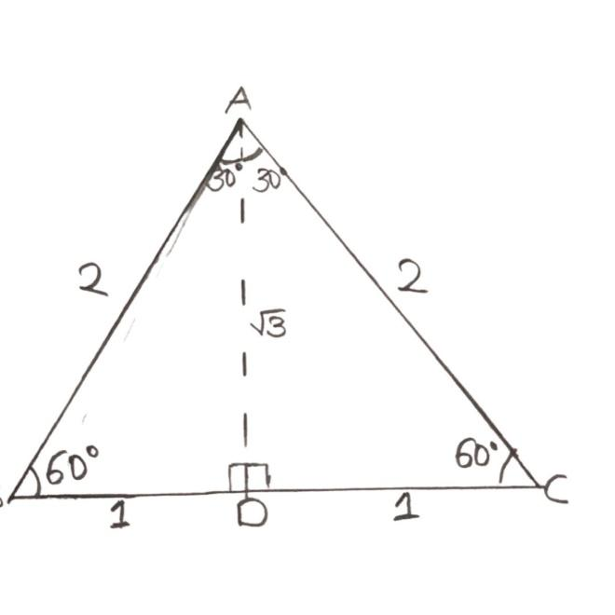

Consider right-angled triangle, ADC, by observation and Pythagoras’ Theorem,
/AC/ = hypotenuse =2, /DC/ = 1, /AD/ = $\sqrt{2^{2}-1^{2}}$ = $\sqrt{3}$
If $θ=30°,$ then /DC/= opposite, /AD/ = Adjacent
Sin 30$°= \frac{1}{2}$; cos 30$°=\frac{\sqrt{3}}{2}$ and Tan 30$°= \frac{1}{\sqrt{3}}$
If $θ=60°, then/AD/$ = opposite and /DC/ = Adjacent,
Sin 60$°=\frac{\sqrt{3}}{2}$; cos 60$°=\frac{1}{2}$ and Tan 60$°= \sqrt{3}$
- Consider a right-angled isosceles Triangle of base angle 45$°$ and equal side of 1
By observation, /AC/ = hypothenuse
By Pythagoras’ theorem,
/AC/ = $\sqrt{{/AB/}^{2}+/BC}/^{2}$
= $\sqrt{1+1}$
= $\sqrt{2}$
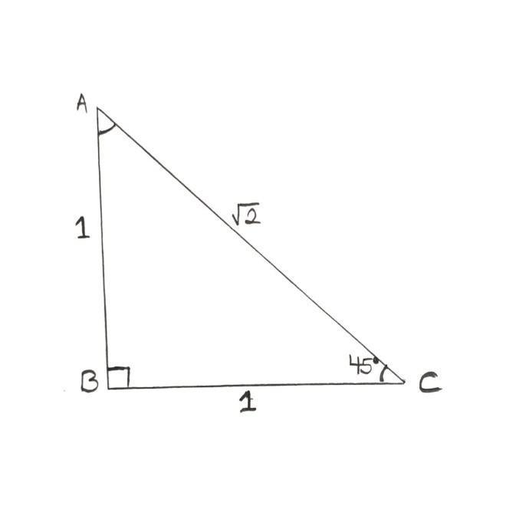

Thus, with $θ=45°,$
Sin 45$°$=$\frac{1}{\sqrt{2}}$; cos 45$°=\frac{1}{\sqrt{2}}$ and Tan $45°=1$
Hence,
$θ=30°,45°, 60°$are special angles whose values are easily accessible. In addition to these angles, $θ=0°$ and $θ=90°$ are also special angles
Since $sinsin θ=0°;coscos θ=1, Tan 0°=0$
Sin 90$°=1;coscos 90°=0;Tan 90°=∞$
Using these five special angles, we can then proceed to draw the graphs of the sine and cosine function within 0$≤x≤360°$
QUESTIONS:
- Consider a right-angled triangle ABC. If AB is 12 and BC is 7, then find the value of the angle at C.
- A circle subtends a right angle at the centre with radius 8m. Calculate the length of the chord that bounds the minor segment.
- Determine the values of the following from the Trigonometric Table
- 35.25$°$
- 58$°$58’
For their sines, cosines and tangents.
- If sin x =$\frac{5}{13}$, find the value of tan x in fractional form.
RECOMMENDATION
- Cardboard sized representation of the Trigonometric Table.
- Cardboard sized representation of the sine and cosine graphs

SOLUTION TO QUESTIONS

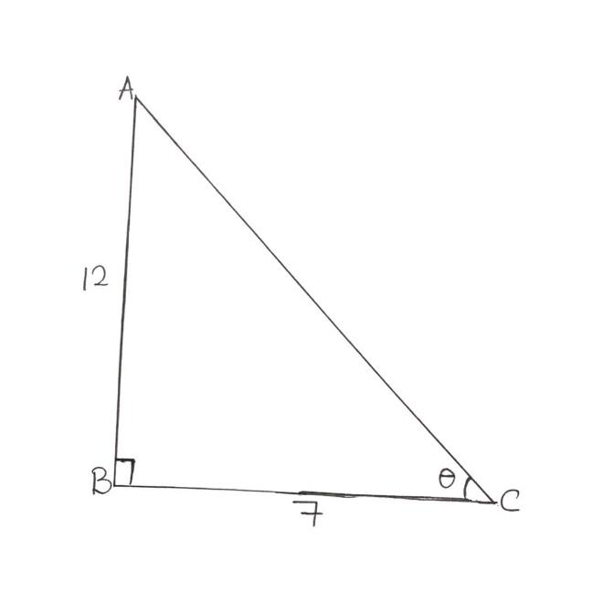

By SOHCAHTOA,
Tan $θ=\frac{opp}{adj}= \frac{12}{7}$
Tan $θ=1.7143$
$$θ= {Tan}^{-1}\left(1.7143\right)$$
$$θ=59.74°$$
- Length of chord = 2rsin $\frac{θ}{2}$
= (8sin($\frac{90}{2}))$
= 16 sin 45
=8 $\sqrt{2 m}$
= 11.3137m
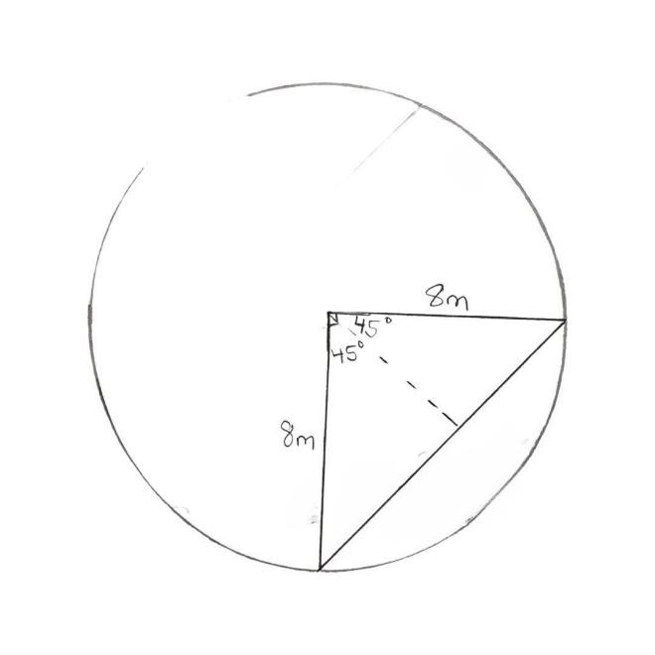

- 35.25$°=35 °+0.25°$
= 35$°{\left(0.25 ×60\right)}^{'}$
= 35$°15'$
- So we search 35 UNDER 12 DIFFERENCE 3 for each Trig. Ratio.
Sin 35.25$°=sinsin 35°{15}^{'}=0.5771$
Cos 35.25$°=coscos 35°{15}^{'}=0.8176$
Tan 35.25$°=Tan 35°{15}^{'}=0.7067$
- 58$°{51}^{'}$ means 58 UNDER 54 DIFFERENCE 4
Sin 58$°{51}^{'}=0.8569$
Cos 58$°{51}^{'}=0.5175$
Tan 58$°{51}^{'}=0.6620$
- Sin x = $\frac{5}{13}$ = $\frac{opp}{hyp}$
Since opp = 5; hyp = 13
By Pythagoras Theorem, ${hyp}^{2}= {opp}^{2}+ {Adj}^{2}$
${13}^{2}$= $5^{2}+ {Adj}^{2}$
${Adj}^{2}=$ ${13}^{2}$- $5^{2}$
= 169 – 25
= 144
= 12
Tan x = = $\frac{opp}{Adj}$ = $\frac{5}{12}$

